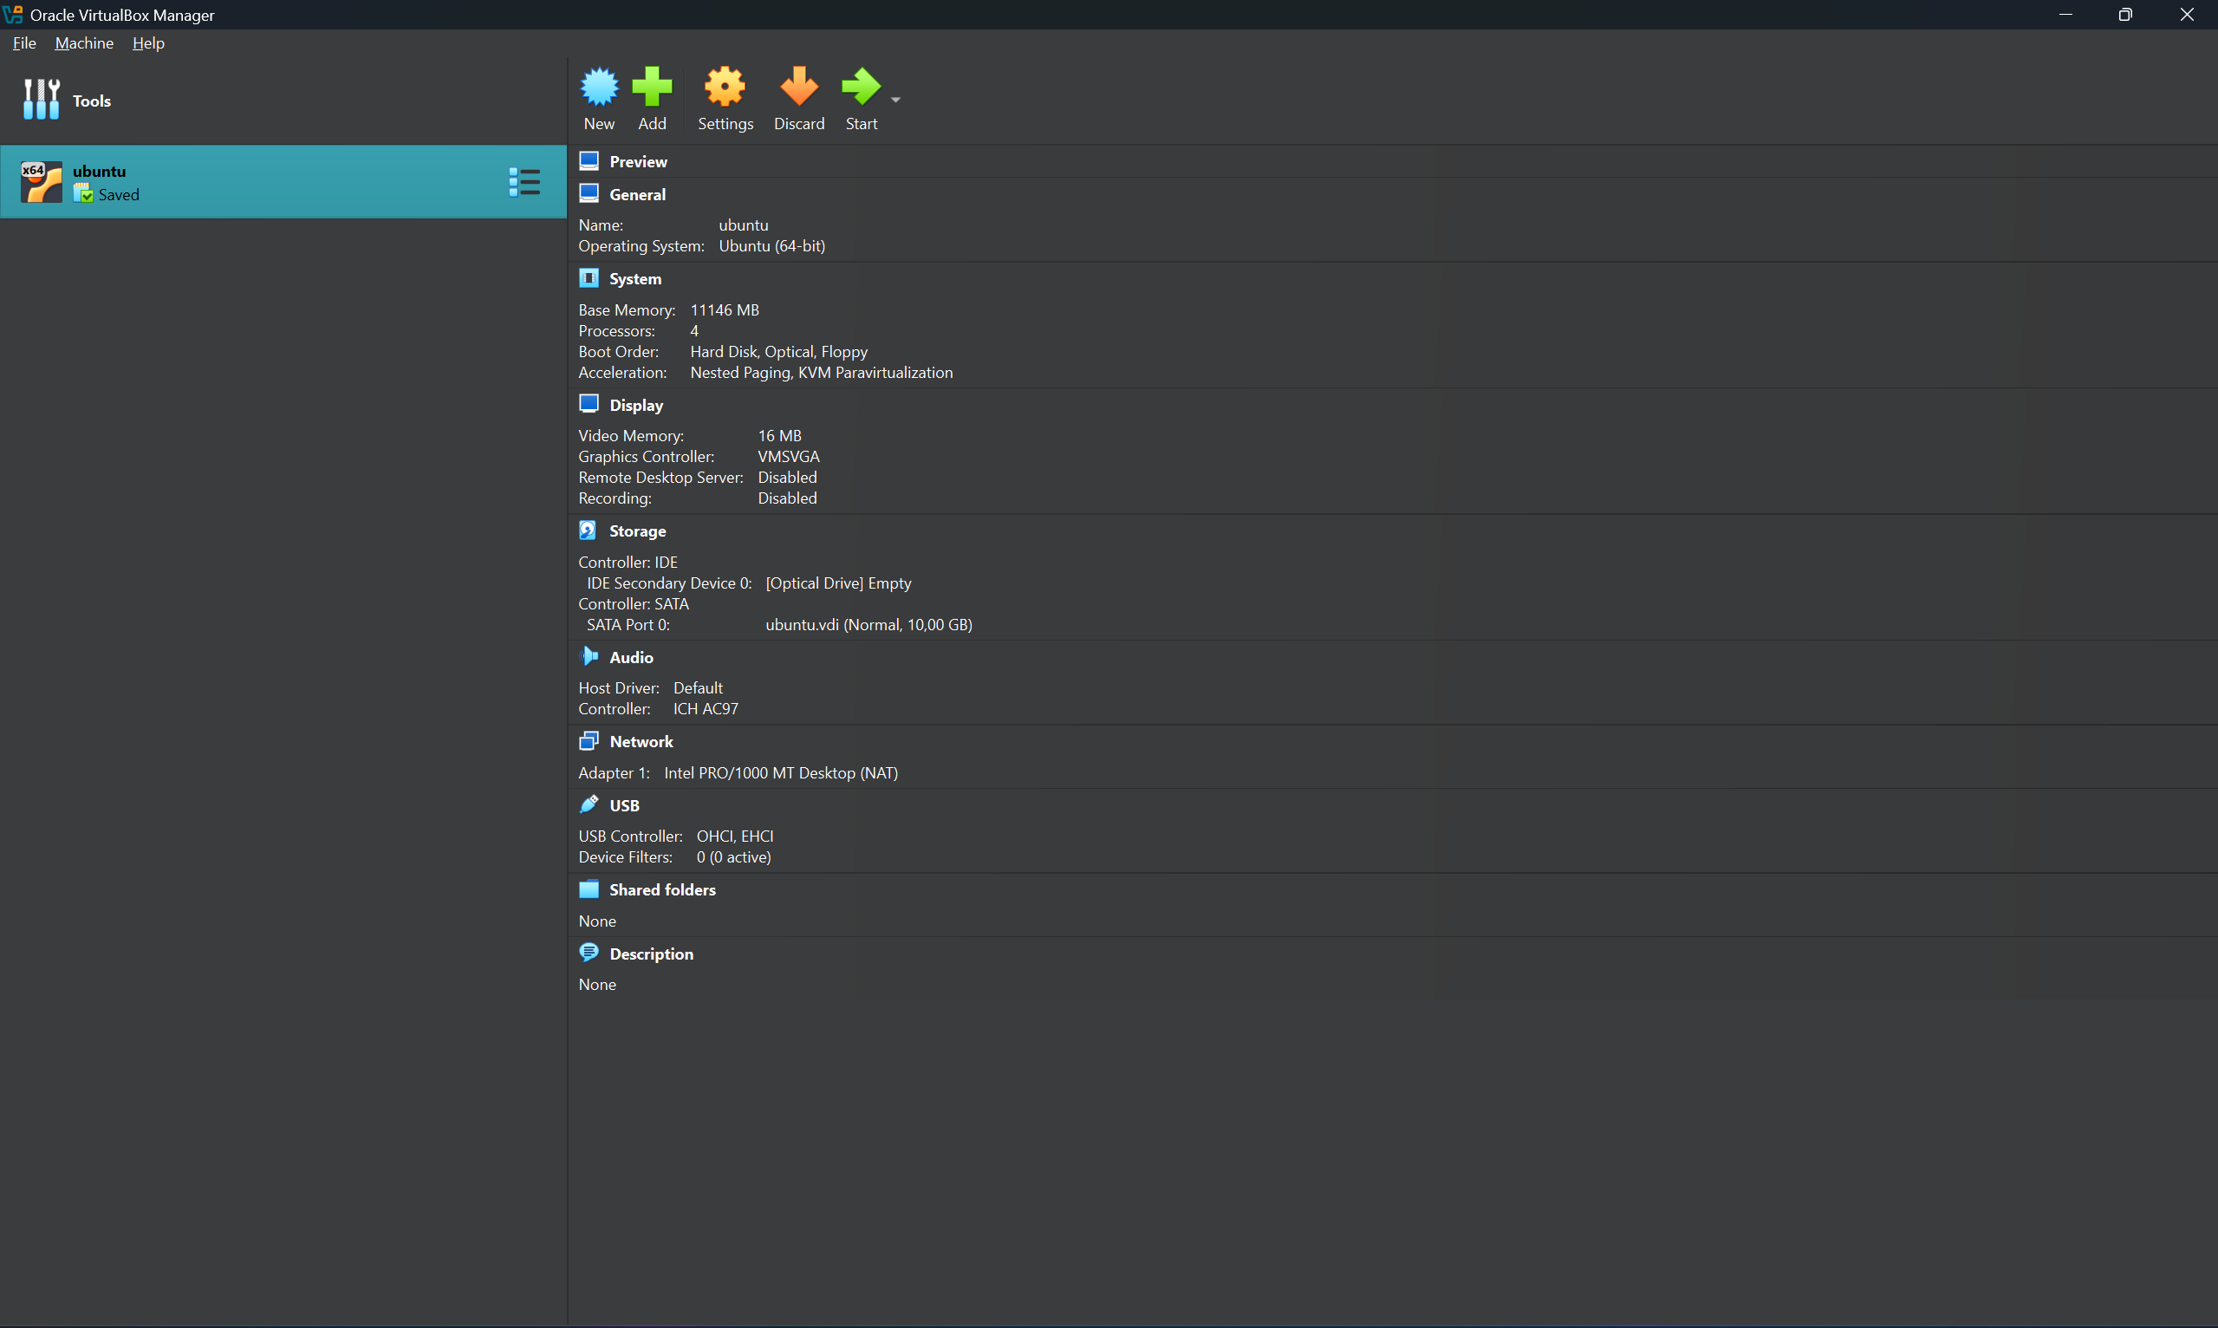
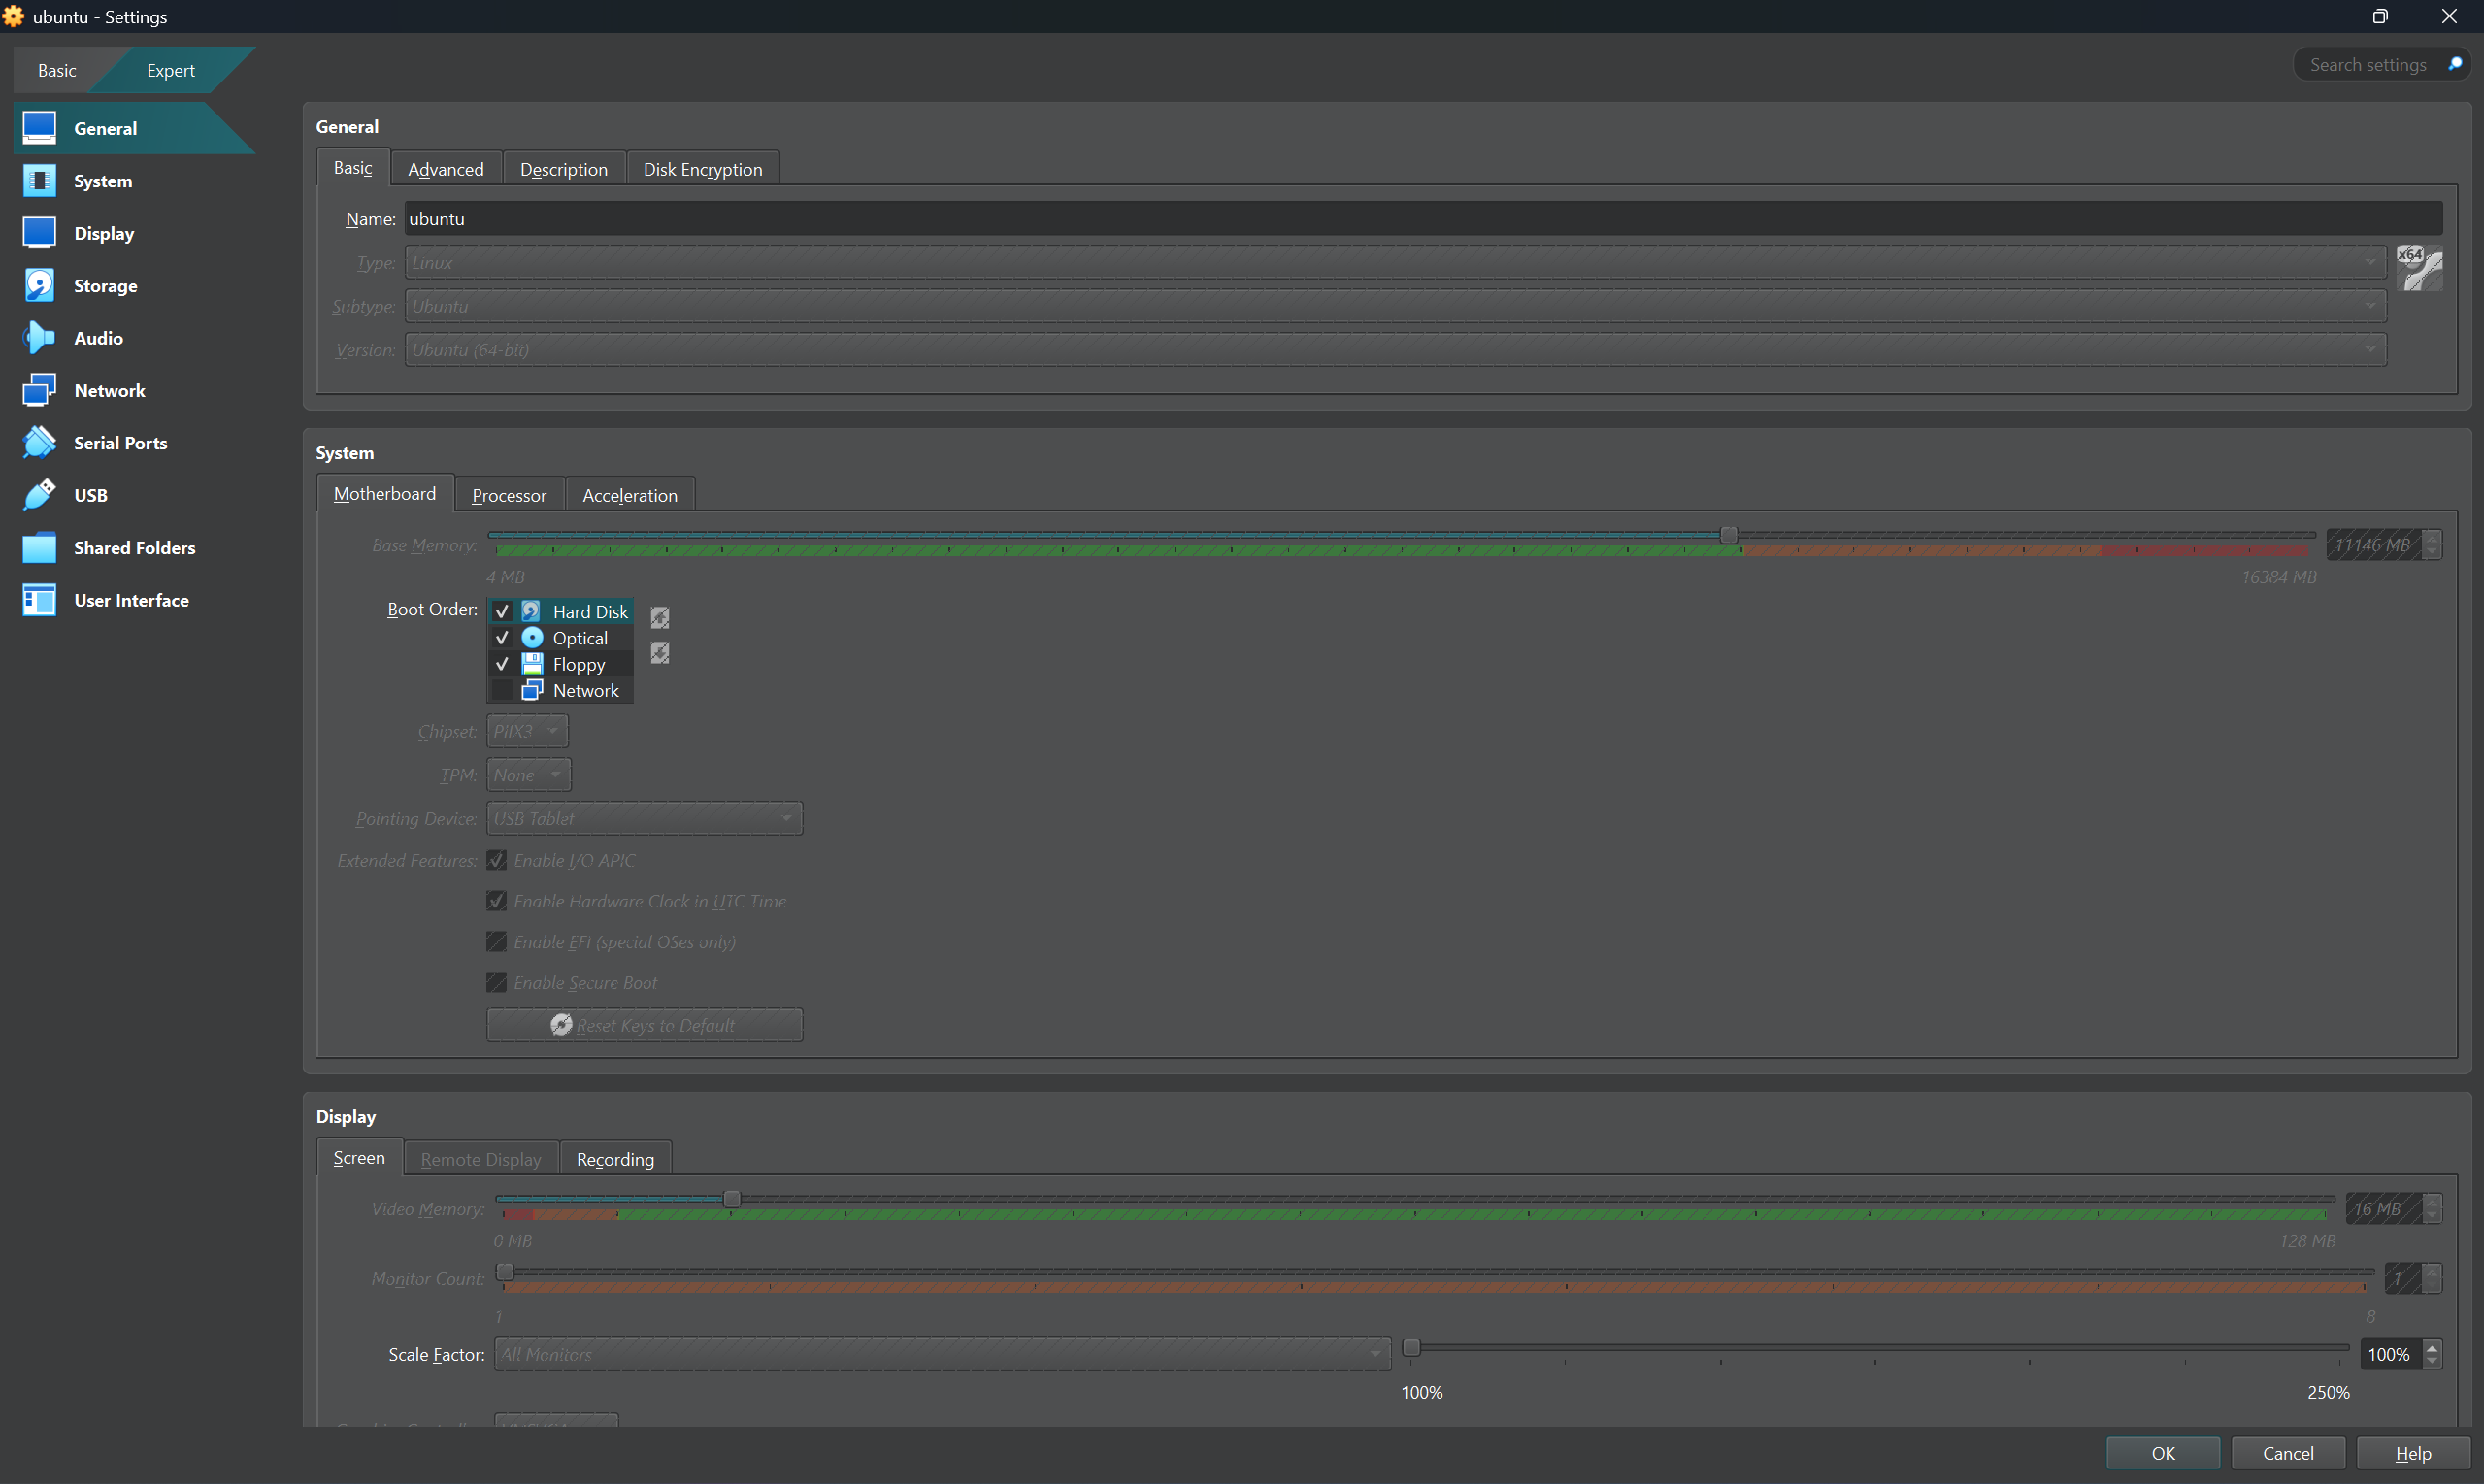
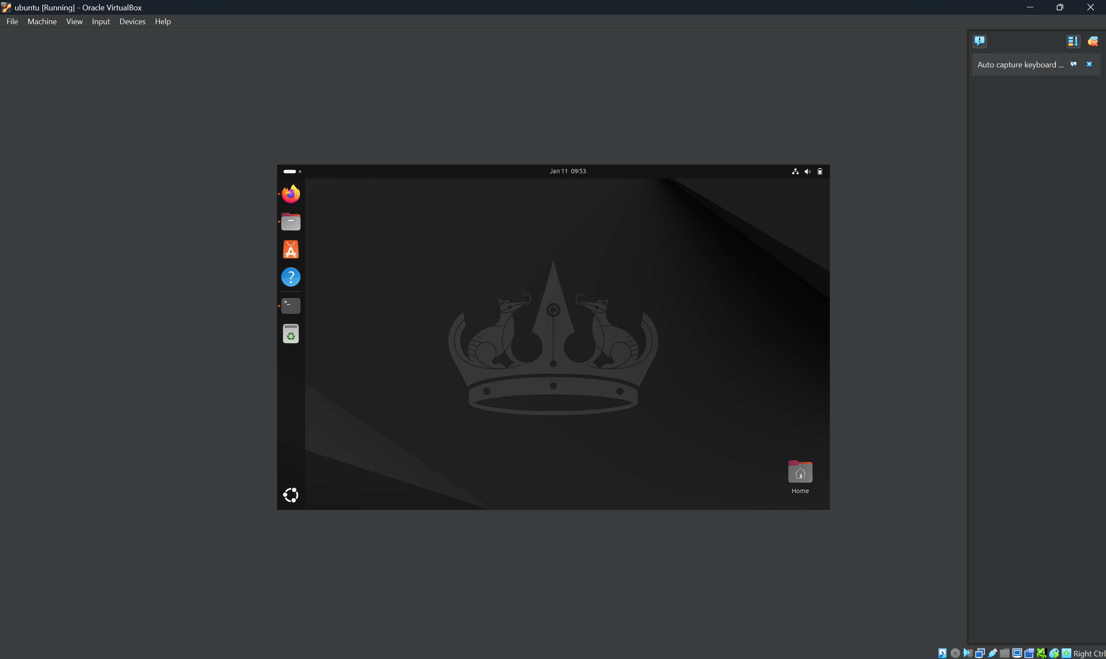
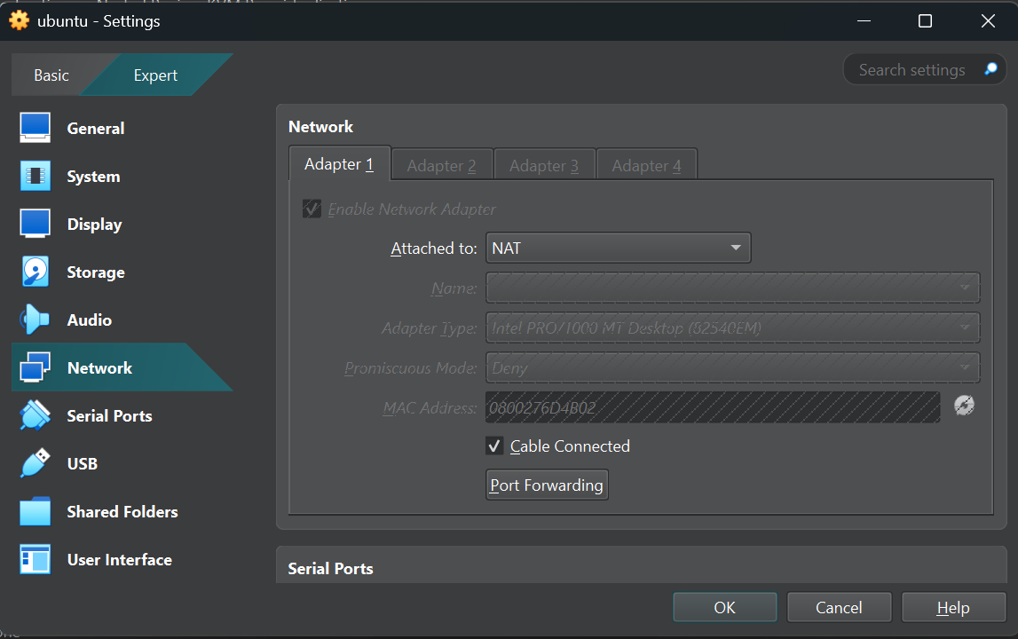
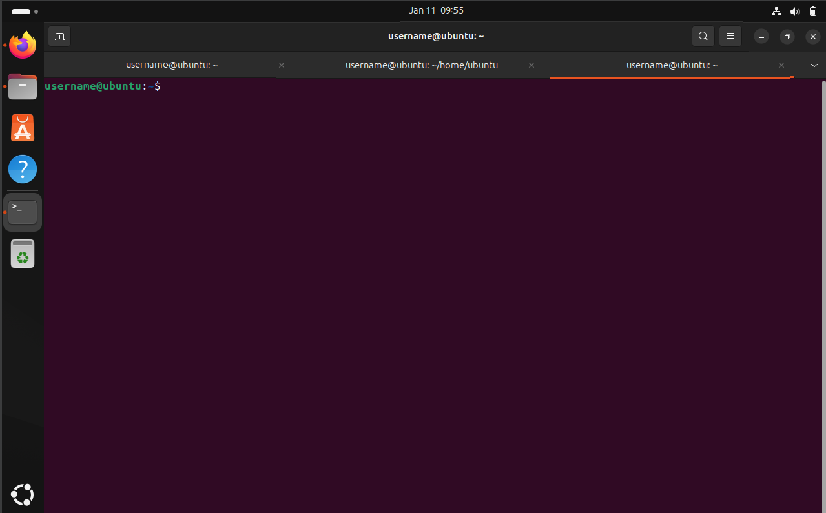Reflection Questions
1. What challenges did you encounter during the virtual machine setup?

2. What did you learn about virtualisation tools and their differences?
3. How confident do you feel using Ubuntu after completing this lab?
4. In what ways can a virtualised Linux environment help in industry scenarios?
5. What would you do differently if setting up another VM?

